ELECTRATHON DRIVE TRAIN

By

Luis Hernandez

Table of Contents:
- Introduction Page 4
  - Description
  - Motivation
  - Function Statement
  - Requirements
  - Success Criteria
  - Scope of Effort
  - Success Criteria
- Design and Analyses
  - Approach: Proposed Solution
  - Design Description
  - Benchmark
  - Performance Predictions
  - Descriptions of Analyses
  - Scope of Testing and Evaluation
  - Analyses
i. Design Issues
ii. Calculated Parameters
  - Device: Parts, Shapes and Conformation
  - Device Assembly, Attachments
- Methods and Construction
a. Construction
    - Description
    - Drawing Tree, Drawing ID’s
    - Parts List and Labels
    - Manufacturing Issues
    - Discussion of Assembly, Sub-Assemblies, Parts, Drawings
- Testing Method
i. Introduction
ii. Method/Approach
iii. Test Procedure description
iv. Deliverables
- Budget/Schedule/Project Management
  - Proposed Budget
    - Part Suppliers, Substantive Costs and Sequence, Buying Issue
    - Labor, Outsourcing Rates and Cost Estimates
    - Funding Source
  - Proposed Schedule
    - Gantt Chart
    - Specific Tasks
  - Project Management
    - Human Resources
    - Physical Resources
    - Financial Resources
- Discussion
  - Design Evolution/ Performance Creep
  - Project Risk Analysis
  - Successful
  - Next Phase
- Conclusion
- Acknowledgements
- References
- Appendix A – Analyses
- Appendix B – Drawings
- Appendix C – Parts List and Budget
- Appendix D– Schedule
- Appendix E- Job Hazard Analysis Form
- Appendix F– Resume
1: INTRODUCTION

1a: Description: Engineer a chain drive to transfer power from the electric motor to the axel in the most efficient manner with minimal cost and highest simplicity.

1b: Motivation: The need for power transfer from the engine to axels, similar to those found in motorcycles or bicycles, using a chain drive. To work on hand with other engineers and in unison to engineer a functional vehicle.

1c: Function Statement: To design, build, and power an electric car for the 2018/2019 Electrathon America electric vehicle design competition. Engineer a drivetrain that will supply the vehicle with enough power to transport a 180 pound driver and the vehicle weight at competitive speeds. All under a budget of $500.

1d: Requirements:
- Drivetrain that can transfer up to three horsepower from engine to axel
- Output RPM of 425
- 25 mph min speed
- Drivetrain weighs no more than 50 pounds
- Direct chain drive
- VR less than 7.0
1e: Success Criteria: Reach between a minimum speed of 25 miles per hour or maximum speed of 30 miles per hour, while constantly accelerating and breaking under racing, fast paced environment.

1f: Scope of this effort: Will be a simplistic, double sprocket transmission from a direct drive chain, much like a motorbike, with emphasis on safety requirements and efficiencies.

1g: Benchmark: There is a similar electrathon project that has been used in the past for racing. After further evaluation, there is much that can be updated for efficiency and power, including using a new electric motor than the one previously used. This will be used as a comparison.

1h: Success Criteria: Success for the drivetrain of the vehicle will be a 25% increase speed from the current expected 25 miles per hour. Further success will be measured in taking first place during the Electrathon America Race as well as creating a durable and reusable design.
2: ANALYSES
2a: Approach: Proposed Solution
This project will come together through the combined intellectual forces of six engineering students. Although an individual project, the students rely on each other’s designs and work in order to complete or enhance their own.
Teamwork is not the unique solution to the project however. For the chain drive, the first step taken was figuring out the requirements; what speed would the vehicle have to achieve? How much will the chain drive weigh? What power will it have to transmit? Under what cost? These were the key requirements under which the design would be modeled after.
Next came conducting research on all types of drivetrains suited for this vehicle. It had to be simple enough for a student to be able to create yet complex enough for it to impose a challenge. It would have to be under a certain budget, $500 in this case, and accessible. There would have to be parts that could be personally manufactured or machined and others that would have to be purchased for the assembly to happen. This narrowed down the search to one viable solution: the chain drive. Not too expensive, efficient, and within the realm of plausibility.
Next came the analyses; starting with one of the given requirements, such as horsepower or input RPM from the motor. Those slowly chained themselves together, solving for one variable in order to calculate another. It is through this chain reaction that the system was calculated and built around the original requirements.
Having done the calculations, next came the drawings and tolerances that came with them. Through Solidworks, these ideas slowly took shape. Tolerances had to be placed and the right fitting had to happen.

2b: Design Description
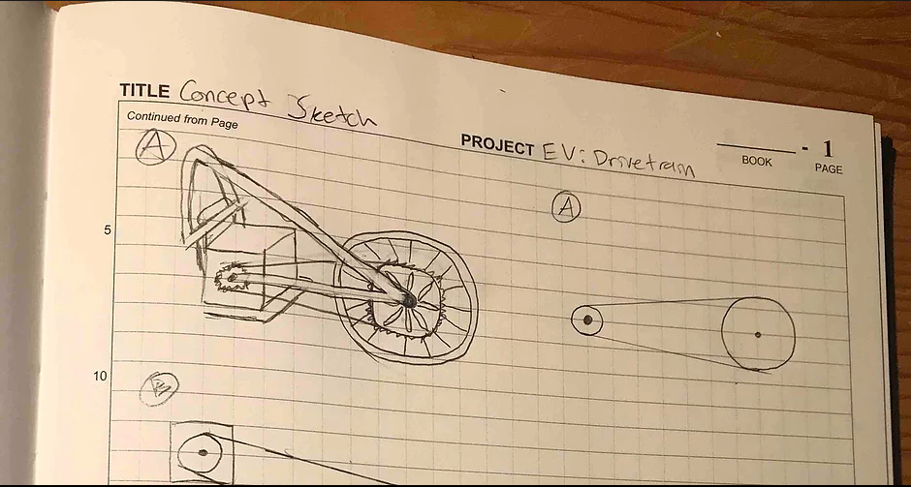
Concept Sketch – Chain Drive

Pictured above is the artist rendition of the chain drive on the EV. As pictured, the electric motor will have to be held in place by some sort of mounting plate that will be bolted or welded onto the frame. The motor itself has various holes from which it can be mounted from and will be located directly behind the driver of the vehicle. The single rear wheel lies between two suspension shocks and in between them will be the driven sprocket mounted to the wheel. This should still have enough clearance to where there will not be any interference between the sprocket or the chain and the shocks.

2c: Benchmark.
There is another electrical vehicle from previous years that is used as the benchmark for this project. It is similar in design to the current chain drive; it has a higher ratio with a larger than average driven sprocket, a smaller than average motor sprocket, has approximately 20 inches of center distance, and uses chain as-well. The benchmark EV is estimated to have a 1 horsepower motor with an output RPM of 2800. The new motor is being held to the same RPM, although this time with three horsepower. The benchmark EV reached a peak speed of 50 mph according to professional sources that have tested that vehicle. This means that the benchmark will be used as comparison when testing is completed on the EV, and that theoretically, the minimum standard of 25 mph is not only achievable, but that the max speed of 30 mph might be too low of a ceiling cap for this project.

2d: Performance Predictions
As stated above, under Analysis 2c: Benchmark, the prediction for this project is that it might be being held to a lower standard than what is capable. Given the previous 1 horsepower vehicle with similar chain drive managed to achieve a speed of 50 mph, there can be alterations done to this one in order to beat the previous speed. The prediction is that it will undoubtedly go beyond 25mph, if the motor runs at its potential. There are many other factors that could affect performance outside of the chain drive realm. If anything it may be a challenge to keep it under 30 mph, which is a capstone that is liable to change in the near future, given the already unusual gear ratio.

2e: Description of Analyses
A-1: Motor Platform Deflection and Forces
A-2: Force and Shear Stress Actin On Keyway
A-3: Design Power, Velocity Ratio, and Chain Pitch
A-4: Required Teeth Calculation of Driven Sprocket
A-5: Pitch Diameter of Driven and Driving Sprockets
A-6: Actual Expected Output Speed
A-7: Required Chain Length
A-8: Calculated, Actual Theoretical Center Distance
A-9: Angle of Wrap on Each Sprocket
A-10: Torque Acting on Motor Shaft and Driven Shaft
A-11: Force in Chain
A-12: Basic Dynamic Load Rating and Ball Bearing Dimensions
A-13: Maximum Torsional Shear Stress in Driven Shaft and Motor Shaft
A-14: Shear Stress Acting on a M4 Screw
A-15: Minimum Required Key Length for Shear and Compression

2f: Scope of Testing and Evaluation
Testing and evaluating the EV will not be too difficult of a task. These can be evaluated using tools which are at the team’s disposal. Speedometers and other light sensors are capable of tracking the EV’s speed and RPM. To test for the weight, an industrial scaled will be used.

2g: i. Design Issue
The design project has not gone without any issues. The first issue is the electric motor being used. The colleague in charge of the electrical components of the EV, the batteries which power the motor, has tested the input RPM of the motor to be approximately 2800. The motor itself however is labeled for 4250 RPM. Whether this is a temporary issue or a permanent one will have a significant impact on the chain drive. The motor shaft is where the entire design of the train drive begins. Altering this would mean recalculating a velocity ratio which would alter the remainder of the design. The velocity ratio is another possible design issue. The current velocity ratio of 6.6, as shown in Analysis A-3, is very close to the recommended VR design limit of 7. Once again, a shift in the input RPM from the motor would significantly affect this. The accessibility to parts, such as a 112 tooth sprocket, is very minimal with the parameters required and not easily found; if they do exist they usually come at a very large price due to the rarity of the part. Lastly, the cost of these specific parts pose a financial problem. Some of the parts can sell for up to $150. As stated before finding a part within an economical umbrella that is not common can be very difficult.

2g.ii: Calculated Parameters
In designing the chain drive, one of the most important design requirements is for the system, as per design guidelines, to have a maximum speed ratio of up to 7.0. Achieving this requirement means meeting a couple other requirements. One of these requirements calls for the motor sprocket to have a minimum of 17 teeth and the driven sprocket a maximum of 120 teeth. As shown in Analysis A-3, the motor sprocket was chosen after calculating the design power and using the table found in the book. The driven sprocket was found using the velocity ratio and motor sprocket teeth number, as shown in Analysis A-4. This larger sprocket has a calculated number of 112 teeth. This falls within one of the parameters and requirements, 17 < N < 120, for the chain drive and also means a velocity ratio of 6.6. The analysis can be looked at more in detail on both A-3 and A-4. The drawings of the sprockets can be found in the Appendix as Drawing B-1 and B-2.
In order for the system to have a speed of 25 mph with a 20 inch diameter wheel, the calculated output RPM, as shown in Analysis A-3, had to be 420 RPM. This presented another challenge because of the required velocity ratio of sub 7.0.The analysis determined the velocity ratio between the calculated output RPM and input RPM to also be 6.6. Then, as shown in Analysis A-6, the actual expected output speed had to fall between 420 RPM and 430 RPM to roughly maintain the same velocity ratio. The result was a median of 425 RPM which meets the requirements and still holds an acceptable velocity ratio.

A-1: The motor for the Electrathon Vehicle is to be mounted on some sort of aluminum platform. Given the dimensions of a 6 inch platform and a 6 inch motor, it is meant to be a snug fit. That being said, with a weight of 35 pounds and small platform, there needed to be a calculation on the forces acting on said platform. This was calculated using beam deflection equation along the x-axis, sum of the forces, and moment-shear diagram as shown in analysis A-1. It resulted in a deflection (Y_{B}) of -0.0003 inches, which is within the bending tolerance of the frame.
A-2: The intent in this analysis was to calculate the force and shear stress acting on the key of the driven sprocket. This was calculated given the input RPM, motor power, and dimensions of the square cross section key. As shown in analysis A-2, the calculated force (torque over radial distance) acting on the key is that of 1,070 pounds. As for the shear stress acting on the key, it was calculated to be 5,348 lb/in². This was found dividing the previous calculated force over the area of the key.
A-3: Analysis A-3 has a lot of crucial information that marks the foundation of the chain drive. The design power, ratio, chain pitch and driver sprocket teeth number were calculated given input speed, desired output speed, safety factor, wheel diameter, and motor power. First, the design power was calculated by the multiplication of the motor horsepower and safety factor. This was calculated to 3.9 hp. The ratio was then calculated by taking the expected output speed of 25 mph and converting it to inches per minute. Then, using the circumference of the wheel, the desired output RPM was calculated to 420 RPM. This means a ratio of 6.6 given the input RPM of 2800. This calculated ratio will be the largest plausible, given the input RPM of 2800 is the absolute maximum the motor can provide. This means all calculations from this point on will be using the maximum possible input speed of the motor, although it may or may not reach these speeds during testing. Given the 3.9 horsepower and table 7-14, the selected chain is a single strand roller chain number 40 with a pitch of 0.5. Last but not least, using the same table, the driving sprocket teeth were found to be 17 teeth.
A-4: Analysis A-4 is a simpler yet important bit of information for the chain drive. Having found the number of teeth the smaller sprocket will have and the system’s velocity ratio; the larger sprocket was calculated to have 112.2 teeth which is rounded to 112 for an even number of teeth. Therefore, the final teeth number for both sprockets is 17 and 112 as shown in Analysis A-4.
A-5: In analysis A-5 the pitch diameter of both sprockets was calculated using the given pitch of 0.5in and sprocket teeth numbers. The pitch was divided by the sin of 180 degrees which was divided by number of teeth N. The result was a pitch diameter of 2.721in for the driving sprocket and a pitch diameter of 17.828in for the driven sprocket As shown in Analysis A-5.
A-6: One of the requirements for the chain drive system is for it to have an output speed range of 420-430 RPM. Given an input speed of 2800 RPM, and calculated 17 and 112 sprocket teeth gave a calculated output of 425 RPM. This fit perfectly in the middle of the required range and works with the calculated sprocket teeth as shown in Analysis A-5.
A-7: Another crucial piece of information that is key to the chain drive and comes to mind for purchasing purposes is the length of the chain itself. This was calculated for given the number of teeth in each sprocket and the center distance (CD) of 40 pitches. This CD was not an actual measurement, but rather an estimate. It is impossible to solve for the chain length without it. Forty pitches were not chosen arbitrarily however; it is the median between the design guideline of 30-50 pitches. These were all plugged in and calculated to a chain length of 150.215, which will be rounded down to an even number of 150 as shown in Analysis A-7.
A-8: As shown in Analysis A-7, the center distance of 40 used was a standard number used with the intention to solve for chain length. Shown in Analysis A-8 however, is the calculated actual theoretical CD of the system. This was found given the calculated chain length and sprocket teeth. The actual distance turned out to be 39.884 pitches which was extremely close to the estimate of 40; this translates into roughly 20 inches give the pitch diameter of 0.5in.
A-9: On of the last calculations regarding the actual chain and sprockets is the angle of wrap between both sprockets. As shown in Analysis A-9, the driving sprocket’s angle of wrap was calculated to 135 degrees. This meets the requirement of at least 120 degrees for the driving sprocket. Lastly, the driven sprocket was calculated to 225 degrees; both were found using their respective pitch diameters and center distance.
A-10: The torque acting on the motor shaft and driven shaft was calculated given the electric motor’s three horsepower, input 2800 RPM and output 425 RPM. As written on Analysis A-10, equation 12-1 from Mott’s Machine Elements in Mechanical Design was used. The equation for the motor shaft and driven shaft remained the same except for their respective RPM. The equation used to solve for torque in this case was 63 thousand times the division between horsepower and RPM. The driven shaft is subjected to 444.7 lb-in of torque while the motor shaft is subjected to a smaller 67.5 lb-in of torque. Given the system is a speed reducer, it makes sense for the much larger sprocket to apply more torque on the driven shaft than the smaller sprocket on the motor shaft.
A-11: The force acting on the chain was calculated for to make sure the right chain with the proper dimensions is being used and can withstand the transmission of force. To solve for this, equation 12-6 from Mott’s book was used. Torque from the driven sprocket was divided by the same sprocket’s radius, the force acting on the chain was then calculated to be 49.61 lbs as shown in Appendix A-11. If done using the motor sprocket, the same force is calculated which backs the original answer.
A-12: The chain drive is meant to transfer power from the motor to the vehicle and therefore make it move. This implies the system will have wheels and therefore bearings. As shown in Appendix A-12, the basic dynamic load rating and dimensions were calculated for single-row, deep-groove ball bearings. Tables 14-4 and 14-3 as well as equations 14-2 and 14-3 were used as reference to solve for the rating and dimensions. From the tables the design life and K-value were found. Design load and output RPM were known from the beginning. Design life, L_{d}, was calculated for, using the given values, and resulted in 3.825 x 10⁷ rev. Using this value along with k factor and design load, the dynamic load rating resulted in 1,179.26 lbs. Manufacturing dimensions were found using the McMaster-Carr website and looking for ball bearings that fit a one inch diameter shaft and supported the dynamic load rating. Steel, 3/8” width, max RPM of 14,500 bearings with dynamic load rating of 2,400 were found and will be used for design of the system.
A-13: The motorized system is bound to cause torsional stress on both the motor and driven shafts. Having calculated the torque on both of these shafts in Analysis A-10 and knowing the surface radius on them, the maximum torsional shear stress could then be found as shown in Analysis A-13. This was first calculated by solving for J, the polar moment of inertia. As shown on the green sheet, the shaft diameter to the fourth power times pi divided by thirty-two will equal the polar moment of inertia. Torsional shear stress was then found, using equation 3-7 from Mott’s book, by multiplying the respective torque by the radius and then diving by J. This resulted in the driven shaft having a maximum torsional shear stress of 2264.84 psi and the motor shaft 343.69 psi.
A-14: The wheels used for the vehicle have a 1.8 inch diameter circle of 6 evenly spaced holes meant for M4 screws. The sprocket is to be screwed onto the wheel itself which raises the question if the screws could handle the chain drive or if they would be sheared off. To find out, the overall force acting on that circle of screw holes was calculated by dividing the torque acting on the sprocket by the radial distance of the said circle. This result was then divided by 6 to solve for each individual screw. The M4 screw nominal stress area was found through a table, and the shear stress was solved for. This was not the final answer, however, as it did not account for the factor of safety. To account for it, the shear answer was multiplied by ½. As displayed in Analysis A-14 this yielded in 2.7ksi of shear stress per screw. This meant a large variety of metals could be safely selected for use and not shear off the screw.
A-15: The motor and driven shaft both have keyways for them to mate with their respective sprocket. There is a large variety of keys of different materials. Thus, as shown in Analysis A-15, given a height and width of ¼ inch, N value of 3, yield strength of 83 ksi, motor and driven shaft torques plus diameters, the minimum required length for shear and compression was able to be calculated for. Equations 11-2 and 11-4 were used as well as tables 11-1 and 11-3. Using said equations yielded four solutions; lengths required for compressive and shear stresses. The motor shaft key required 0.039 inches due to shear stress and 0.013 for compressive stress. The driven shaft key required 0.257 inches due to shear stress and 0.0857 inches due to compression. Therefore, the keys must be at a minimum of 0.257 inches in order for them to work if used with steel 1095.

2h: Device: Parts, Shapes and Conformation
The look of the chain drive was inspired by a couple of other similar projects. The benchmark project that was built before has an electric motor mounted to the frontal steering bracket which contains one wheel. The team decided to maintain that same look, except have the single wheel in the rear of the vehicle instead of the front. This way the steering and drive train are two separate entities. The current EV will have a fixed chain drive that will look similar to how the benchmark’s is mounted. The other inspiration that determined the look or feature were chain drive motorcycles. They have the fixed rear tire and chain drive but with functional shocks and body. It is the goal to achieve a similar look and functionality.

2i: Device Assembly, Attachments
Within a chain drive, there are multiple components in the assembly. These components include the driven sprocket, driver sprocket, motor shaft, driven shaft, ball bearings and chain, for example. These can all be observed in Appendix B-1 through B-6. There are individual devices, however, that are not necessarily part of the assembly, yet they supplement it. These are, for example, the bracket that will be bolted to the electric motor, or the bracket to retain the ball bearings.

2j: Tolerances, Kinematics, Ergonomics
Parts such as chains and sprockets do not have many tolerances due their required manufactured precision for a costumer. Other parts, however, such as single-row, deep-groove ball bearings or the drive shafts do have significant tolerances as shown in drawings B-4, B-5 and B-6. The bearings, for example, have an OD tolerance of -0.0005 inches and the drive shaft has an OD tolerance of -0.003 inches.
The kinematics behind the chain drive forced a significant amount of requirements for the system not to break down. For example, Analysis A-11 calculates the force acting on a moving chain. This value is then compared to the manufacturers note on chain strength. A key between the shaft and sprockets is another kinematic area in the system. As shown in Analysis A-15 and drawing B-6, the key too is important for the mechanism to work. As it turns out, the whole chain drive is essentially full of kinematics. This is shown throughout the analyses and drawings.

2k: Technical Risk Analysis, Failure Mode Analyses, Safety Factors, Operation Limit
The biggest technical risk the chain drive faces is the financial one. Due to the limited budget behind the project, there exists the risk of having to purchase cheaper or smaller sprockets simply to fit budget and end up re-calculating to make the design parameters work. With a large enough budget, there would be a very high chance of the design working according to plan.
Another risk facing this project is scheduling. With the limited budget possibly having to alter much of the design the road, there simply is short amount of time before the competition in April. There is very little room for error or changes once construction begins.
Safety in design was accounted for during the design process. For example, the motor runs at 3 horsepower as seen on Analysis A-3, yet with a factor of safety it goes up to 3.9 for safety purposes. When calculating the shear stress on each individual screw for the sprocket-wheel mating, there was a factor of safety of ½ that was accounted for in Analysis A-14, as well as another factor of safety in Analysis A-15.
The EV chain drive will naturally have an operational limit due to the speed reducer. The driver will not be able to exceed speeds of 30 mph due to design.

3. METHODS AND CONSTRUCTION

Once all drawings are in place, they will be mated to create the system through Solidworks. It is at this point in which the parts will be researched for purchase. If any part is too expensive for the budget, or near impossible to make, changes will be done to the analyses, drawings, and naturally the overall system to accommodate for those; so as long as they meet the requirements.
Once all the parts have been figured out and purchased/made, the construction phase will begin. The parts will be mated physically in order to be able to conduct testing on the chain drive. If any issues were to arise with a specific part, it would be looked at from the analysis and altered to meet standard once again. The same will happen if the drive fails to meet requirements, even if the system is already built. This process will continue until the best chain drive fist that meets all requirements is complete and tested for, only then will it conclude the solution.
Approximately ¾ of the parts will be purchased with the remaining ¼ machined. These parts will be the fasteners that hold the bearings, the mounting brackets for the electric motor, adjustments to the key and shafts.

3.a.i. Description
The chain drive begins with the mounted motor, bolted just behind the driver seat. The 1 in diameter, keyed shaft is attached to the motor. Mated to the motor shaft is the 17 tooth sprocket with the ¼”x ¼ “key. The chain, with an angle of wrap of 135.48 degrees around the driving sprocket also wraps around the 112 tooth driven sprocket with an angle of wrap of 224.52 degrees. This driven sprocket is bolted to the six screw holes on the wheel. The driven shaft goes through the wheel and mates with the sprocket as they share a ¼”x ¼” keyway as well. On both ends of the driven shaft there are ball bearings which are held in place by machined fasteners.

The mount assembly connecting the motor and frame is composed of twelve different parts. Bolted with four 1/2”-20, 1-3/8” long bolts, the motor fits snug to the steel motor mount’s 4.5” diameter hole; it is intended for the face with the driving shaft of the motor. The bottom of this mount is flush with an angle iron are held together by two 3/8”-16, 1-1/4” long bolts. The other face of the angle iron has three holes that are bolted with the steel motor mount base plate with three ½”-13, 1-1/4” long hex bolts. The base plate is a quadrilateral with a 23” long size and a 21” short size. Flush with the edges, forming upside down Ls, are the steel motor mount base plates. These will be welded to the mount base plate, which in turn will be bolted with six ¼”-20, 3” in long hex bolts to the EV frame, along the equal, smallest sides of the quadrilateral.

3.a.ii. Drawing Tree, Drawing ID’s
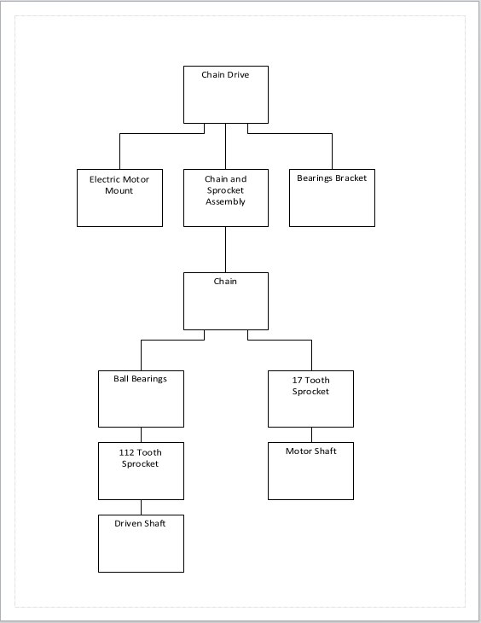

B-1: The drawing shown in Appendix B-1 is a rough, initial design of the driving sprocket. As with every drawing or prototype in the proposal, it is liable to change in the future during the building phase. That being said, assuming it is the correct, final sprocket, it will have; seventeen teeth, a pitch diameter of 2.721 inches, a ¼”x1/8” keyway, and two 5/16in- 18x5/16 set screws. It will be made of steel, although as mentioned in the drawing, the manufacturer does not specify which kind. The sprocket has an overall tolerance of +- 0.0003 inches. It is intended for use with a No. 40, 1/2” pitch chain. Lastly, the drawing in Appendix B-1 is ANSY 14.5 compliant.
B-2: The drawing shown in Appendix B-2 is the driven sprocket. It has 112 teeth, a pitch diameter of 17.828 inches, ¼”x 1/8” keyways and two 5/16in- 18x5/16 set screws. It was manufactured for a No.40, ½” pitch chain.
B-3: The ½” pitch No.40 chain is 75 inches long and made of steel, which is not specified by the manufacturer which is shown in Appendix B-3..
B-4: The single-row, deep-groove ball bearings have an OD of 2.0 in and tolerance of -0.0005in. The ID is 1.0 in with tolerance of -0.0004 in. The bearings have a wid
th of 0.375 inches, maximum RPM of 14,500 and dynamic radial load capacity of 2400 lbs as shown in Appendix B-4.
B-5: They keyed shaft has a ¼ “ x 1/8 “ keyway with a 4 inch length. As shown in Appendix B-5, the shaft is 9.85 inches long and has a diameter of 1.0 in with tolerance of -0.003 in. The shaft has yield strength of 58,000 psi, being 1117 carbon steel. Lastly, it has a 0.075 in x 45 degree chamfer on both ends.
B-6: Appendix B-6 contains the drawing of the shaft key; a 4 inch long, -0.125in tolerance, 1095 spring steel key. The end dimensions are 0.25in ±0.015in.
B-7: The assembly drawing of the motor shaft and driving sprocket is meant to give an idea of the mating between the two using a key. This can be seen in Appendix B-7.
B-8: The assembly drawing of the electric motor mount culminates drawings B-9 through B-12 for an assembly meant to withstand the weight and movement of an electric motor.
B-9: Steel motor mount is the direct attachment to the driving shaft side of the motor. This part attaches to B-10 and is responsible for holding the motor up.
B-10: The angle iron could be considered the bridge between the motor and base mount itself. It is crucial to the positioning of the motor and angle at which the chain strays from the driven sprocket.
B-11-1: B11 is split into two drawings; B-11-1 is identical to B-11-2 other than the fact one is 23 inches long and the other is 21 inches long. Both will be welded to the base plate and form a c-channel to sustain the motor’s weight.
B-11-2: As mentioned before, it’s the identical copy of B-11-1 with a length difference.
B-12: The motor base plate is an eight inch thick steel plate that will be welded together with both B-11 to form the c-channel. It will support and distribute the weight of the motor to the EV frame.

3.a.iii. Parts List and Labels
- Electric motor mounting plate
- Mounting brackets (x4)
- ME0909 PM DC 4000W Electric Motor
- ¼”x1/8” keyed 1in diameter shaft (x2)
- 17 tooth 2.721in PD Sprocket
- 112 tooth 17.828in PD Sprocket
- No. 40 ½ Pitch 75in long steel chain
- No.40 Connecting Link
- ¼”x ¼” x 4 in 1095 spring steel shaft key (x2)
- Single-row, deep-groove, 2,400 lbs dynamic load rating ball bearings 1in ID (x2)
- M4x0.7mm, 60mm long hex head screw (x6)
- 4in x 4in x 3/4in ball bearing fastener (x2)

3.a.iv. Manufacturing Issues
The most prominent manufacturing issue is working with what is available. The bicycle wheel used for the rear wheel drive is going to have to be mated with the large 112 tooth sprocket. Although there are a couple of methods around this, there is going to have to be additional manufacturing changes to the ordered parts. Another issue is managing to align and retain the ball bearings with a manufactured bracket from the machine shop. Although in theory it all should work, theory does not always match the application.
In manufacturing the motor mount there has been a number of issues. At first, 1/8” thick scrap steel was going to be machined as the motor mount base plate. After consultation however, it was deemed too expensive to machine as such due to ribbing and prior modification of the part. Thus a 2’ x 6” steel slab will be used and machined instead. The L-bracket/angle iron was going to be arguably bent; however ¼” in steel is not easy to bend and thus becoming a manufacturing issue. Instead the angle iron will be purchased as such or a change to at least 1/8” thick steel to bend.

3.a.v. Discussion of Assembly, Sub-Assemblies, Parts, Drawings
The first thing to be assembled will be the motor mounting bracket onto the vehicle. Adjustments to it will be made before the rest of the chain drive is assembled to pre-determine where the motor sprocket will seat and if anything else is in the way that needs to be moved or worked around. The driven sprocket will be bolted down with all 6 screws onto the wheel and the driven shaft with the key will be mated to the sprocket. The wheel should be dependent on the sprocket and shaft then. The motor sprocket will then be mated its motor shafts and keys to ensure there is a proper fit and the key works. Once the motor sprocket and driven sprocket are assembled, the rear wheel shaft will have the bearings mounted onto it and then secured into the vehicle’s frame at the bearing fasteners. The last thing to do will be to put the chain on the system.

4. TESTING METHOD

4i.Introduction
The primary testing intentions for the EV chain drive are to ensure that the vehicle goes the intended speed and properly works as the reducer it was intended to be. Failure to meet these requirements could mean forfeiting the race or even worse, someone being injured. If the system is intended and design to go certain speed, it would be extremely unsafe for the driver to it go otherwise. That is the importance of testing the chain drive for the EV.

4ii. Method/Approach
The parameters set for the EV were mentioned earlier in the proposal. The EV is to travel between 25mph and 30mph and have an output RPM of 420RPM to 430RPM. A speedometer will be measured the EV’s speed and an instrumentation light sensor will track the output RPM.

4iii. Test Procedure
Prior to entering the race, the vehicle will be tested in a safe straightaway zone where testing can be conducted. Using a speedometer, the car will accelerate for 100 meters, at which point, the person with the speedometer will record the speed. For output RPM, the EV will be lifted from the rear so the rear drive wheel is not in contact with the floor. The EV will be ran as if it were in track. With a light sensor instrument, the output RPM will be measured to ensure the gear reduction is working as intended.

5. BUDGET/SCHEUDULE/PROJECT MANAGEMENT

5.a. Proposed Budget
i. Part Suppliers, Substantive Costs and Sequence or Buying Issues
All of the parts ordered will be purchased from the McMaster Carr website. Any possibility for a recycled part from previous projects will be used and annotated. Due to the budget constraint and high cost of parts, there will not be any back up or otherwise additional experimental parts purchased.
ii. Labor, Outsourcing Rates and Cost Estimates
There is no labor or outsourcing rates, as manufactured parts will be created by the student and the entirety of the project will be assembled by the student. Therefore, the only labor hours being used are by the student. The total cost estimate for this project is approximately 500 dollars. Cheaper parts or alternative methods will be annotated for future reference and in order to maintain cost efficiency a priority.

iii. Funding Source
The main funding source will be through a club membership for the electrical vehicle. By forming a club between all the engineering students working on the EV, the club will be able to receive up to $2,000 for the vehicle. It will be divided up accordingly between all sections of the EV. If more money is needed, other clubs will be able to financially help the cause. Laslty, if more money is needed then, it will be paid out of pocket by the student requiring the part. The budget for the chain drive and part list is shown in Appendix C.

5.b. Proposed Schedule
i. Gantt Chart
As the shown in the Gantt Chart, Fall Quarter was almost entirely designated for analyses and design. As it turns out, it is easy to underestimate an analysis or a drawing, and something that should have taken one hour can easily take three or more. This chart will assist in time management and estimation. According to the Gantt Chart, a significantly large portion of the time was spent working analyses and drawings for the proposal. As a matter of fact, the build up to the proposal was not as work intensive as the final weeks leading to the end of the Fall Quarter. This is largely due to mismanagement of time. It is estimated approximately 165 hours were spent during the quarter on senior project.

ii. Specific Tasks
With the end of the Fall Quarter coming rapidly to an end, there are specific tasks that are set for when the Winter Quarter begins. First on the list is the bracket for the electrical motor. As mentioned previously on the proposal, it is detrimental to have the motor properly positioned and lined up before continuing with the rest of the chain drive. That is why three weeks of work will be slotted to simply work on the bracket and ensure its success. Another specific task will be the manufacturing of the bearing fasteners. This will take place on the second week of winter and will take over priority as the motor bracket is constructed. Lastly, the remainder of the quarter will be spent making sure the chain drive works and meets parameters for the April competition. The Gantt Chart is also located in Appendix D.

5.c.Project Management
i. Human Resources
Scheduling and conflict of ideas happens regularly when six students try and come together to engineer an electrical vehicle. Managing peers becomes harder and with everyone on a different path towards the same destination, it makes that much harder to depend on one another. Best source of human resources are the faculty in charge of the charge for when the team fails to come to an agreement or mutually fail all together.

ii. Physical Resources
Although not in large abundance, there are some physical resources located around Houge Hall. Aluminum or steel are often seen around, different epoxies, and most of all recycled past senior projects. This makes it easier on the budget and can lead to more manufactured parts to work with. Otherwise, reaching out to plants or large industries and asking for their residue is not far out of the ordinary as-well.

iii. Financial Resources
As stated before on the budget paragraph, the team will create an EV club which will allow for $2,000 to be distributed and spent between the sections of the EV. If that does not suffice, the team members are part of another club which has the financial resources to cover the rest. The project should in no way, shape, or form even exceed $4,000. Therefore, the EV team and chain drive section should be financially stable.

6. DISCUSSION

- Design Evolution/ Performance Creep
Chain drive was not the first idea to come to mind when asked to design a drive train for the EV. It was in the top three, however, along with shaft drive and belt drive. For the first week or so of the project, the design was almost certainly going to be belt drive. This is probably due to Harley Davidson manufacturing their world renowned motorcycles with belt drives. So despite a heavy bias, motivation, and personal drive, why make the change? It was simply not right for the job. Belt drive can be significantly more expensive than a chain drive. A college budget would not afford it. Then there was the argument that belt drive is more reliable than chain and has a much longer design life. Although these were all true arguments, there simply was no reason for it. The vehicle would be driven a few times and the person to take over it next might not have wanted to run a belt drive. To top it all off, chain drive has more torque and is the most efficient of the three previously mentioned drives. Although the thought of shaft drive did cross the mind for a brief second, its complexity, inefficiency, and high price were immediate disqualifiers. Therefore, chain was the ultimate solution.
Next, the discussion of whether to have it be a front wheel drive or rear wheel drive came up. This went in hand with whether to have two wheels in the front and one in the rear or vice versa. It was then decided that for sake of simplicity the drive train would be with the single wheel. The student in charge of steering then decided to have frontal, two wheeled steering, which cemented the chain drive’s position in the EV. All together there has been little to no significant changes to the system since. This is without a doubt bound to change once the building phase begins and changes have to happen.
Design manufacturing issues with the electric motor mount arose with the first prototype. A 1/8th inch thick, ribbed piece of steel scrap was donated for the good cause of manufacturing a mount that could hold 35 pounds worth of electric motor. The initial manufacturing design called for cutting the edges off and drilling onto the scrap piece. The ribbing would have provided a strong mount for the motor to operate on. The issue lay in cutting the edges of a ribbed, heat treated piece. Manufacturing the part would have cost more problems, time, and money than buying steel and designing from scratch.
The following design resembled a c-channel. A flat, 1/8” thick, steel sheet was purchased along with two 24” flat bars. They will be cut accordingly, as shown in appendix drawing B-11 and B12, drilled, welded and lastly bolted on the frame. A 1.5” x 1.5”, ¼” thick angle iron will mount the motor on to this c-channel, as shown in drawing B10, effectively creating the electric motor mount assembly. Not only is this design more feasible to manufacture, it was relatively cheap and the c-channel ensures its strength is unquestionable for the task.

ii. Project Risk Analysis
There is a certain risk involved whenever there are moving parts. Needless to say, caution and proper PPE should be taken whenever working with the electrical motor, chain adjustment, or sprockets. The Job Hazard Analysis Form can be seen in Appendix J. Another risk is a flaw in design and have the EV go the incorrect speed, or have something break due improper calculations and put the driver’s life in danger. In any case, proper equipment should be always be worn.

iii. Successful
Without a doubt, the most successful achievement from a quarter of design was having a velocity ratio below 7.0 with the given motor specs and achieve a speed of 25-30mph. Where the success lacks though is the size of the sprockets. They lie in both extremities of chain drive design, with the minimum number of teeth recommended being 17 and the maximum 120, both push the limit. Perhaps during construction or in a later date, there will be time to adjust to a more standard pair of sprockets.

iv. Next Phase
The next phase for the chain drive is the construction one. As stated before, it will commence with the manufacturing of a mount/bracket for the motor and a mechanism to keep the bearings locked in place. Following this will be the assembly of the sprockets, shafts, bearings, and chain. All together it should conclude before April, when the EV competition is being held.

7. CONCLUSION

The Electrathon drive train design has had success during the Fall Quarter and is ready to begin the next phase of construction. As it stands on paper, it will be ready to meet the design parameters and overcome the challenges of competiton. This is demonstrated in Analysis A-3 and A-4, where the velocity ratio remained under 7.0 and both sprockets stayed within suggested design parameters of no less than 17 teeth and no more than 120 teeth. All in order to have the vehicle move 25-30mph with a given 3HP, 2800 input RPM electrical motor and have an output RPM of 425. Although nothing is certain in life, the chain drive design phase was surely a success.

8. ACKNOWLEDGEMENTS

First and foremost, this design project couldn’t have been made possible, not safely at least, without the mentorship of the CWU MET faculty; Dr. Johnson, Professor Pringle, and Dr. Choi. These fine gentlemen gave their best guidance and help when needed the most. They are great engineers and leaders for the on-coming generation of engineers to look up to. Last but not least, the best team of student engineers anyone could have the pleasure of working along with. A smooth sea never made a skilled sailor, and all those countless hours in the lab will certainly come to fruition for the “C-Team” of engineering.

9. REFERENCES

-“Machine Elements in Mechanical Design” Sixth Edition, Robert L. Mott

-www.mcmaster.com

APPENDIX A – Analyses
Analysis A-1: Electric Motor Platform

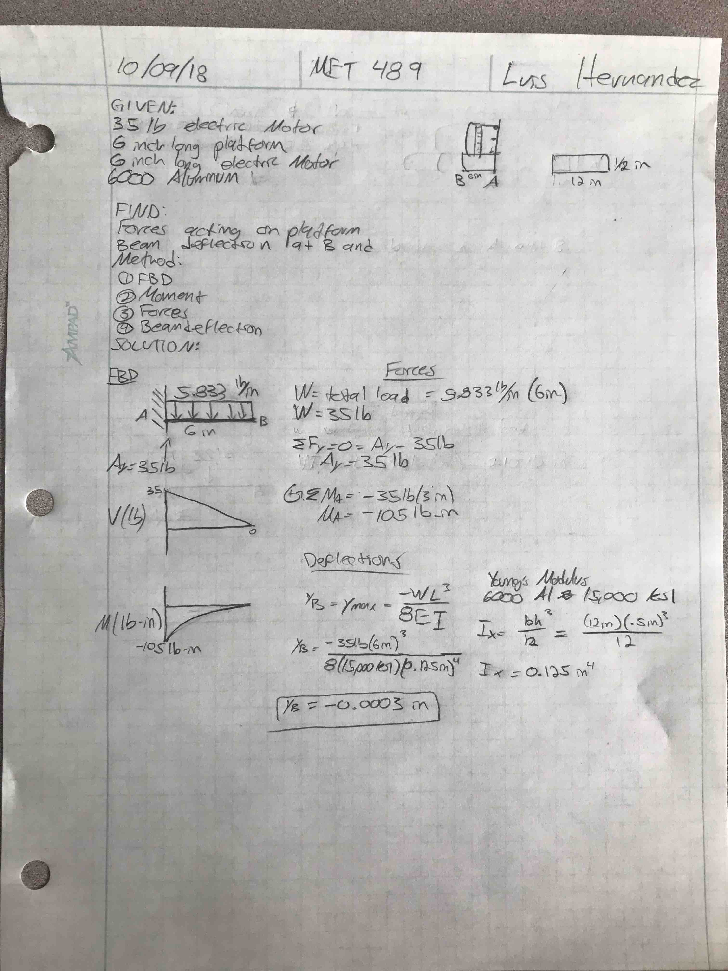
Analysis A-2: Force and Shear Stress Key Driving Sprocket
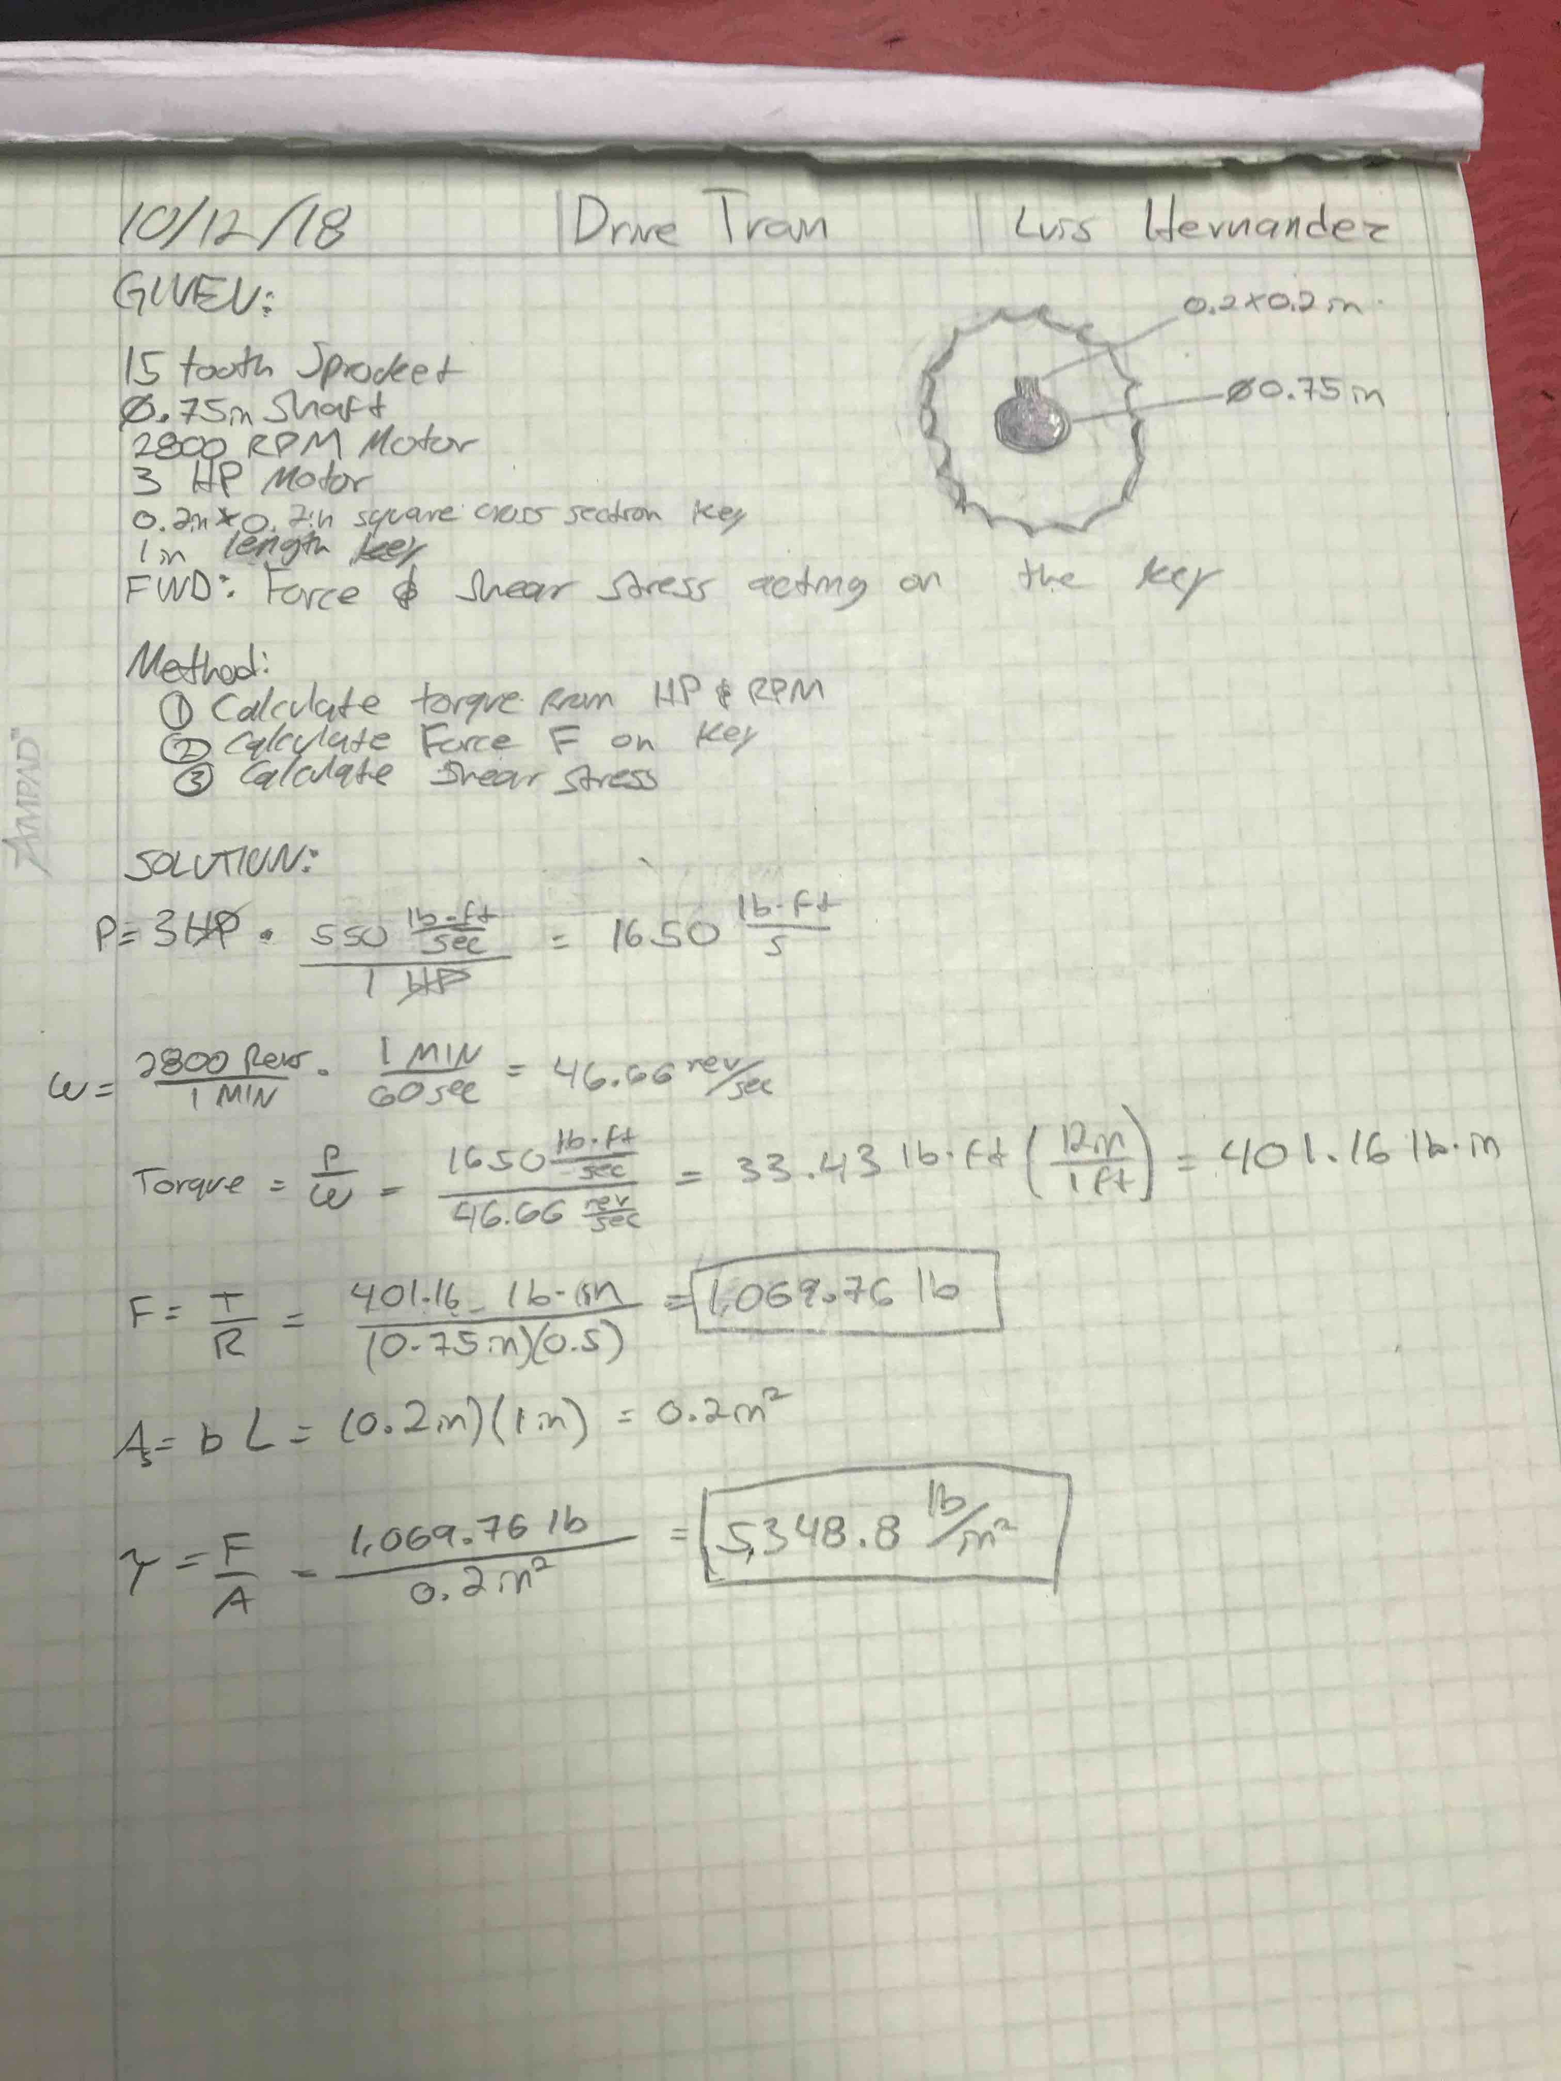
Analysis A-3: Design Power, Ratio, Chain Pitch Analysis
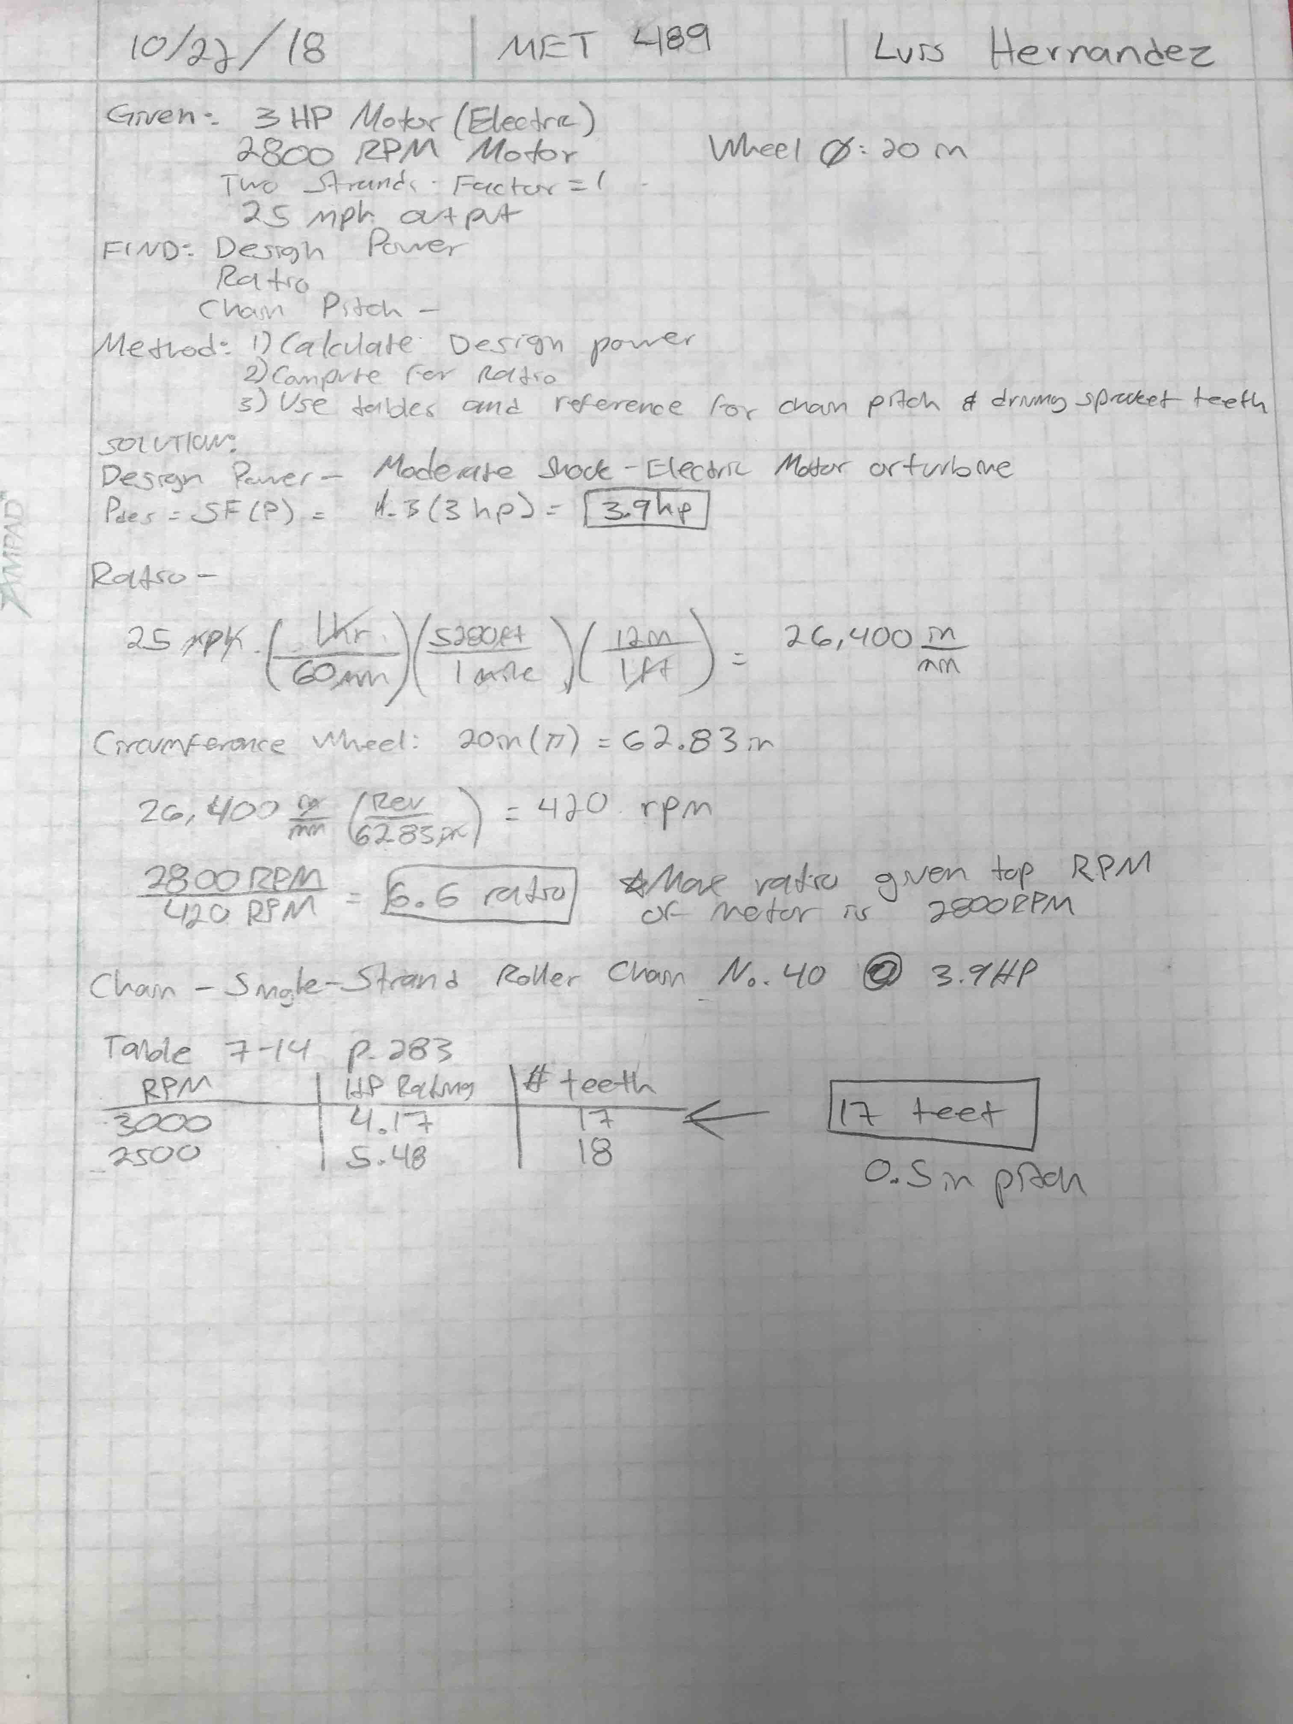
Analysis A-4: Required Teeth on Driven Sprocket
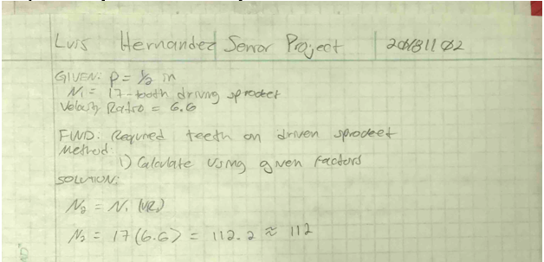
Analysis A-5: Pitch Diameter of Sprockets
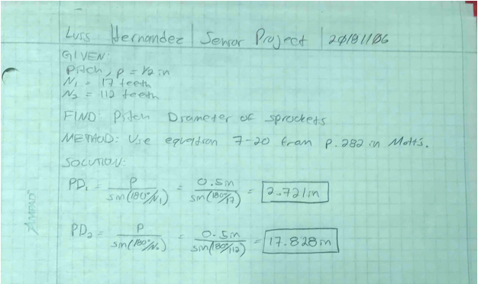

Analysis A-6: Output Speed
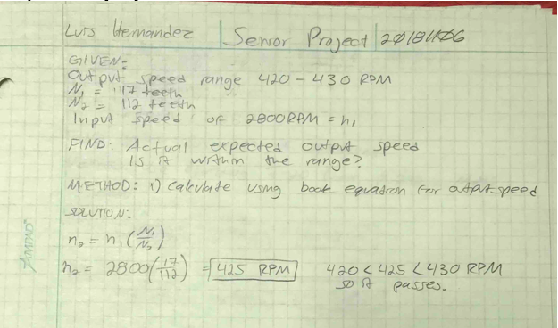
Analysis A-7: Required Chain Length
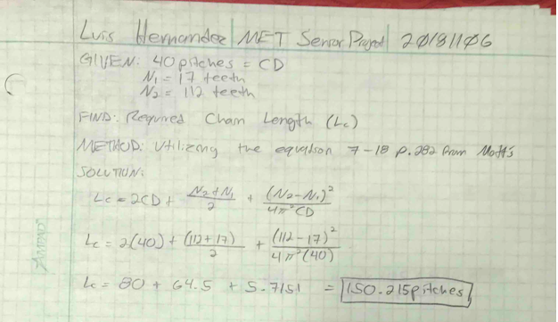

Analysis A-8: Theoretical Center Distance
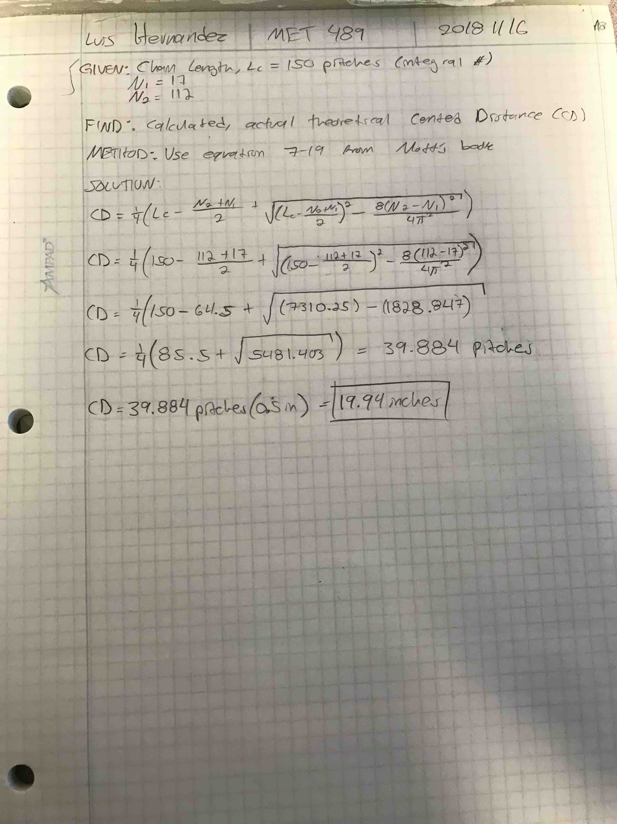
Analysis A-9: Angles of Wrap
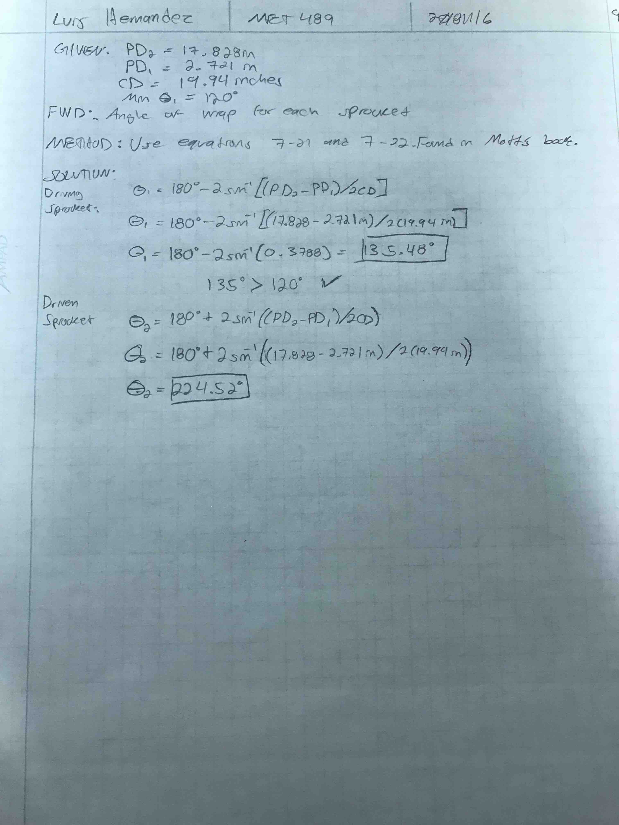
Analysis A-10: Torque on Motor Shaft and Driven Shaft
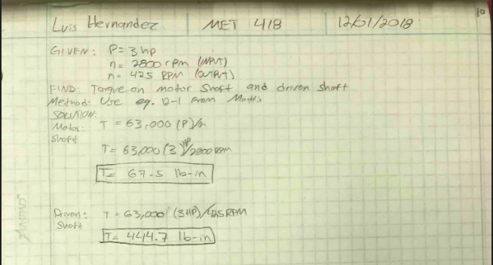
Analysis A-11: Force in Chain
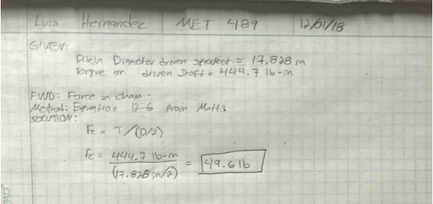

Analysis A-12: Basic Dynamic Load Rating and Ball Bearing Dimensions
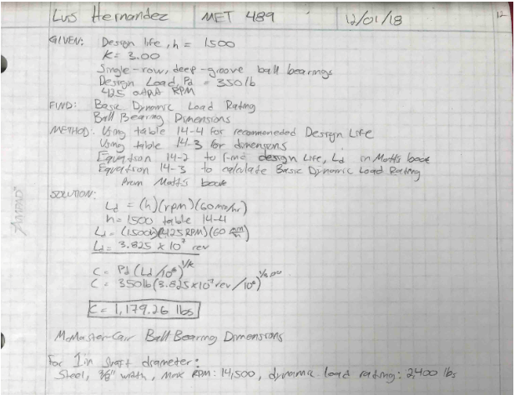

Analysis A-13: Max Torsional Shear Stress in Driven Shaft and Motor Shaft
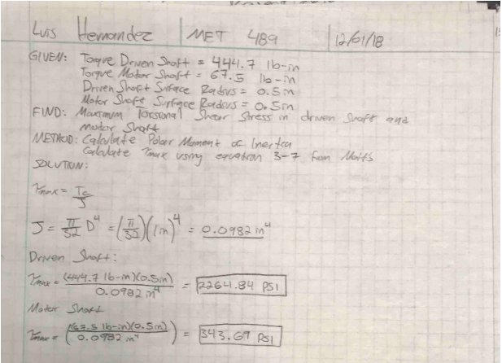

Analysis A-14: Shear Stress Acting on M4 Screw
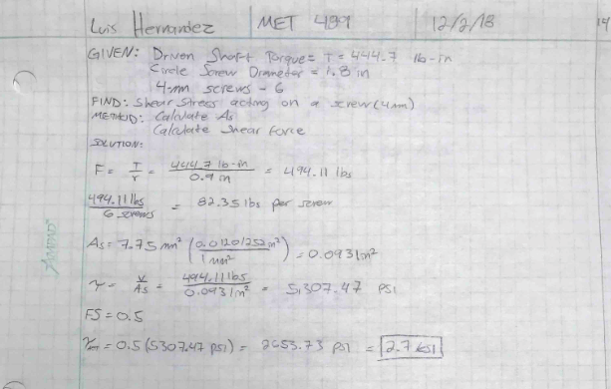

Analysis A-15: Minimum Required Key Length
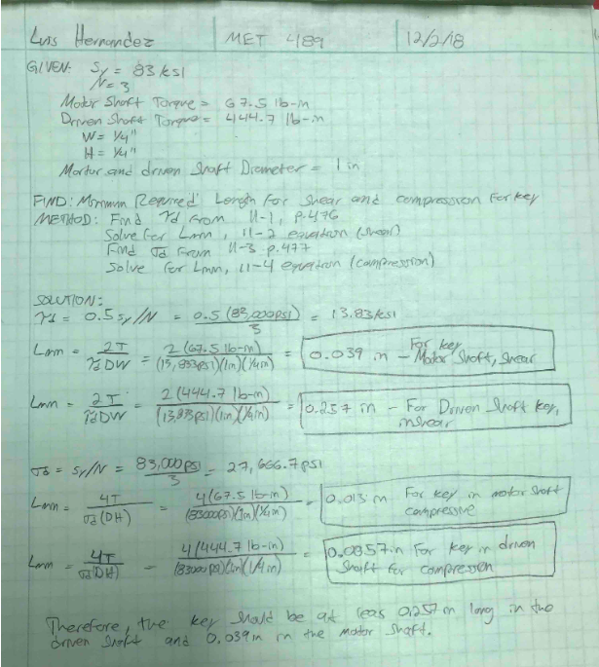
APPENDIX B – Drawings

Drawing B-1: Driving Sprocket
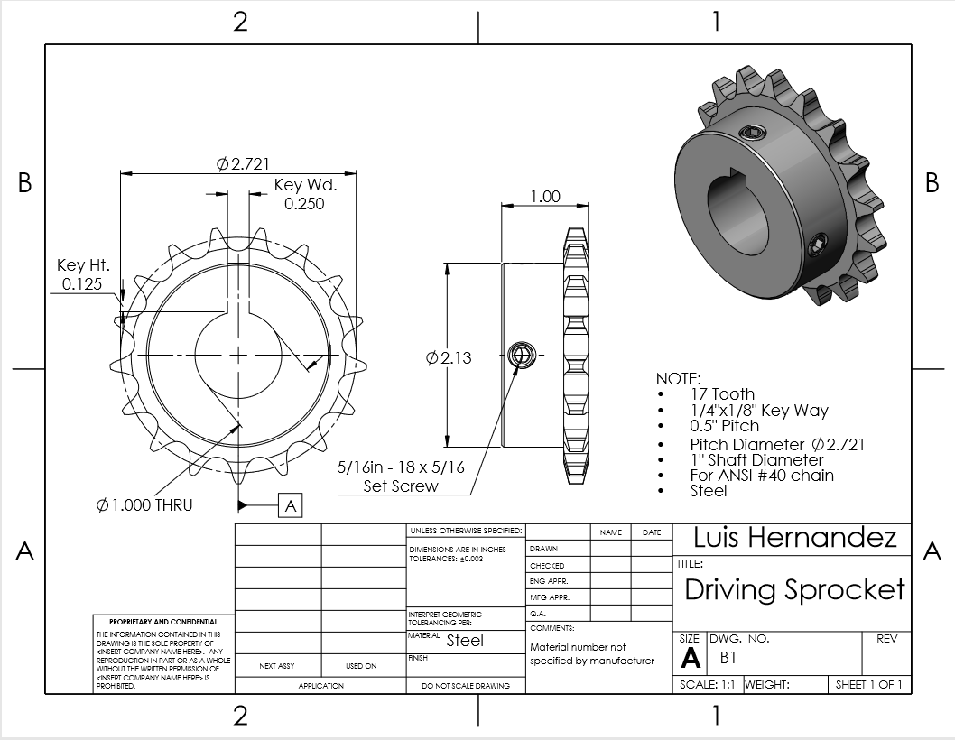

Drawing B-2: Driven Sprocket
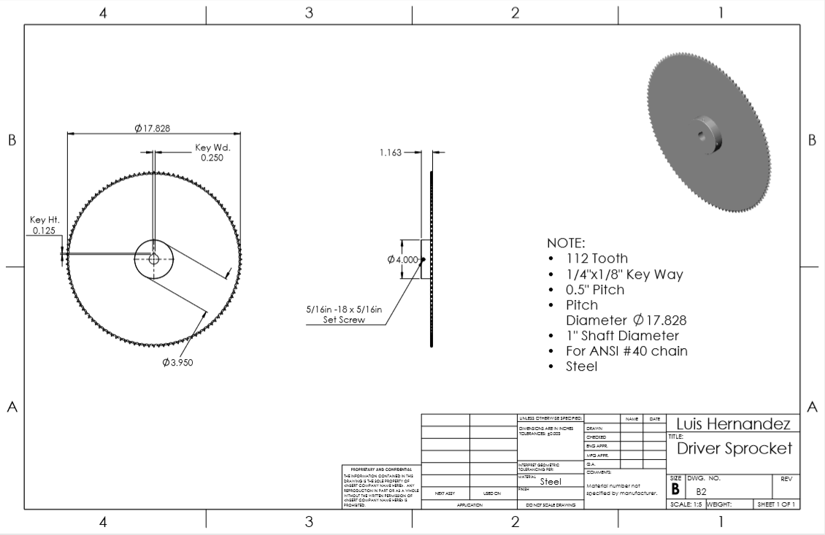

Drawing B-3: No. 40 Chain
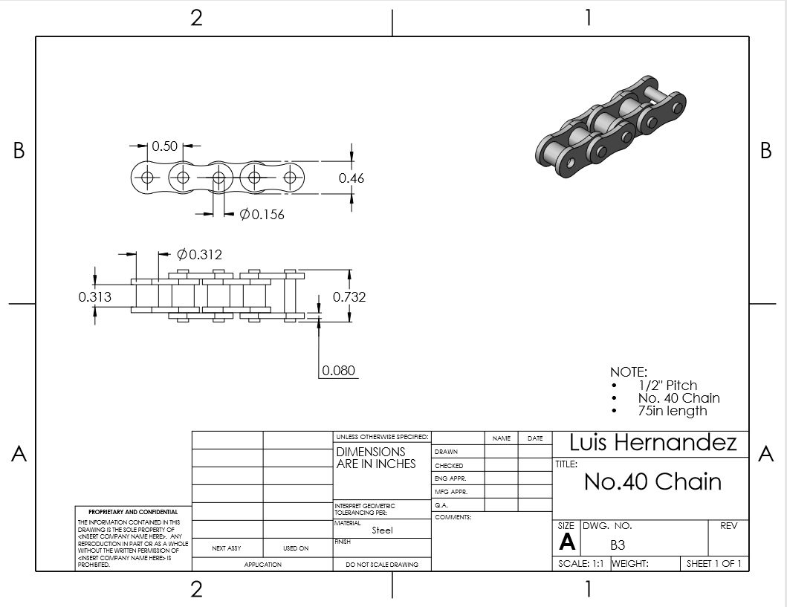

Drawing B-4: Ball Bearing
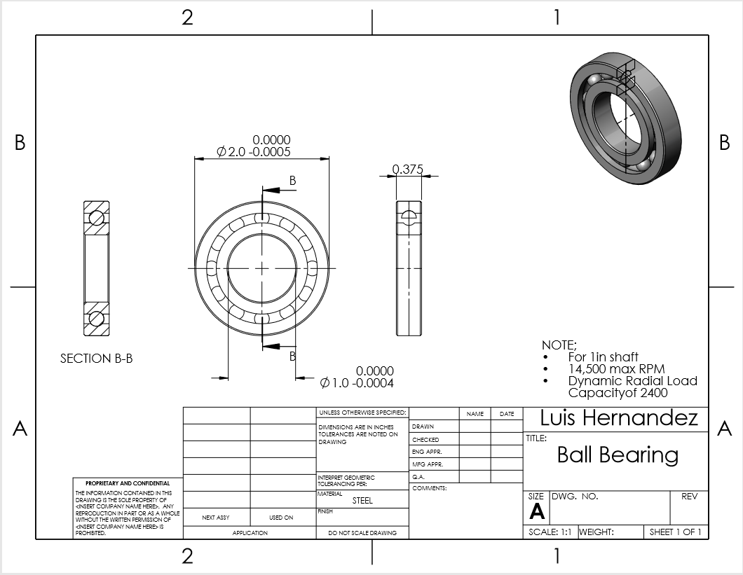

Drawing B-5: Keyed Shaft
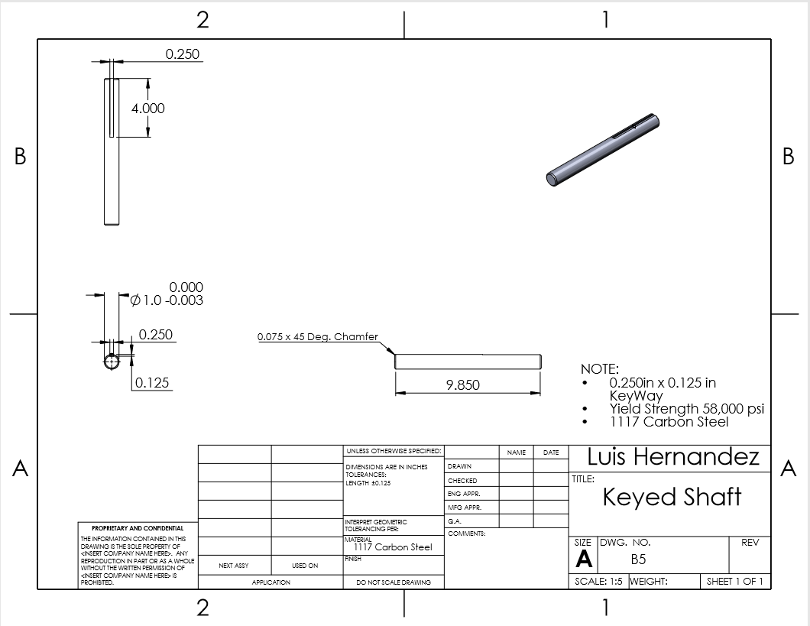

Drawing B-6: Shaft Key
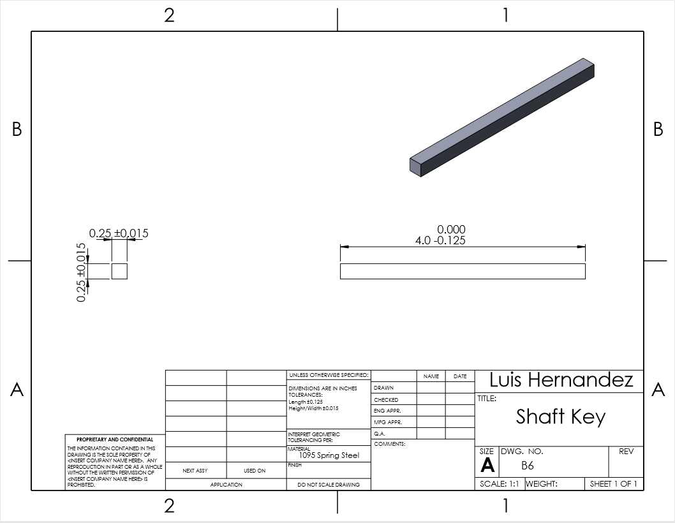

Drawing B-7: Motor Shaft and Driving Sprocket Assembly
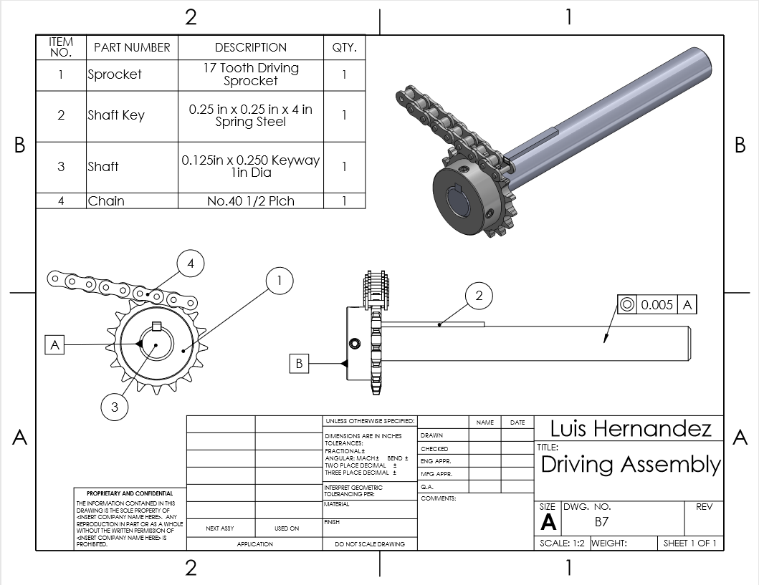

Drawing B-8: Motor Mount Assembly

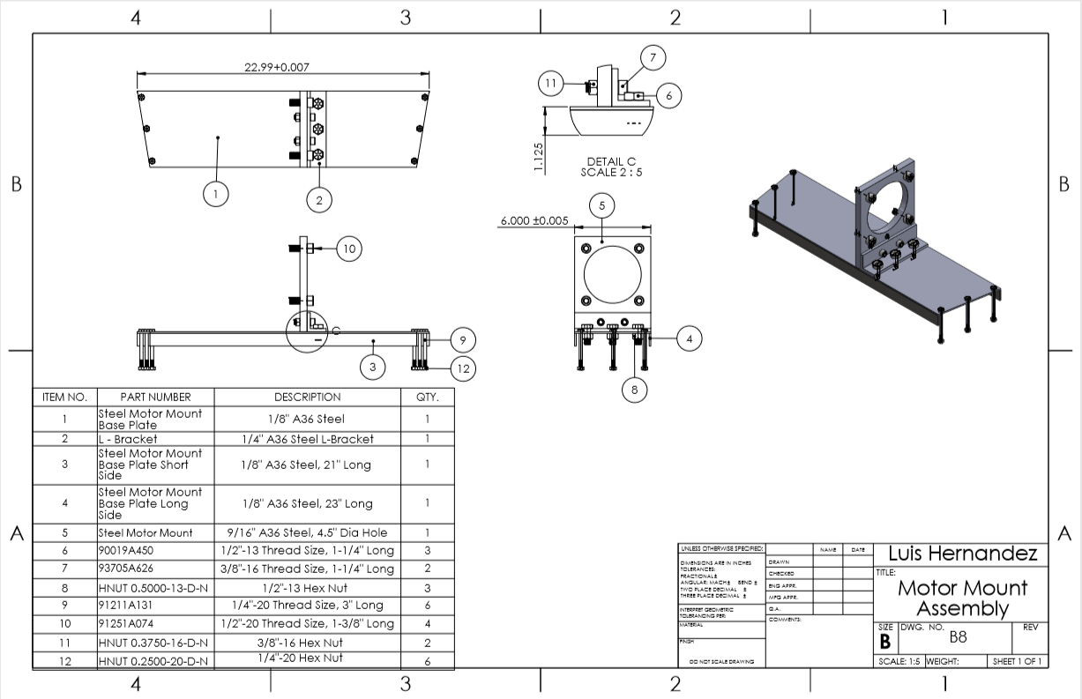
Drawing B-9: Steel Motor Mount

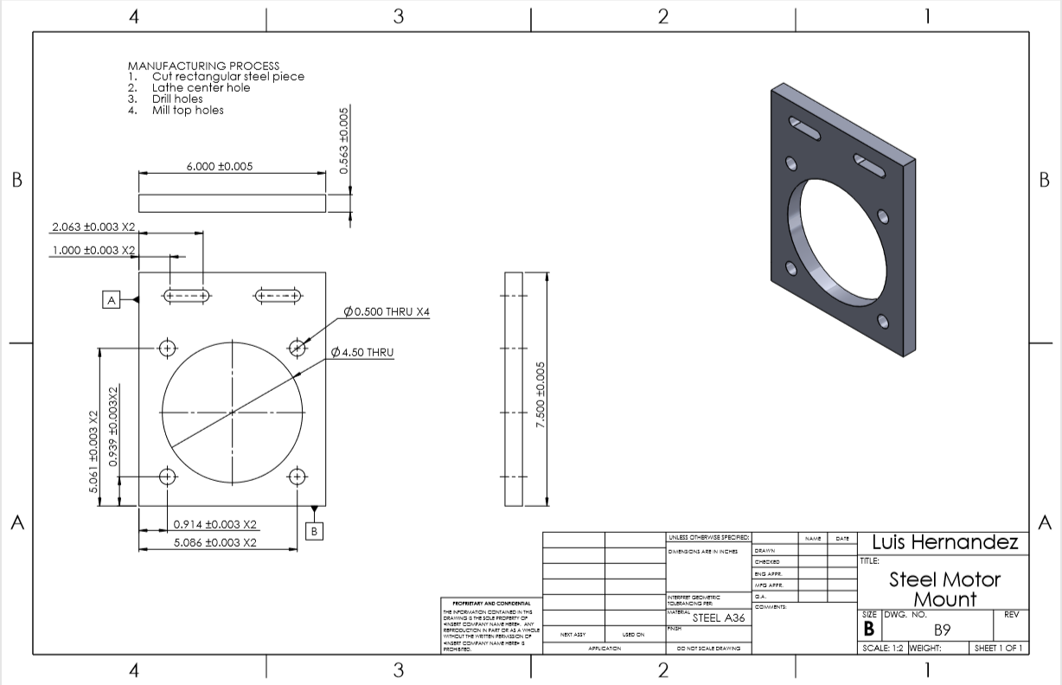
Drawing B-10: L-Bracket

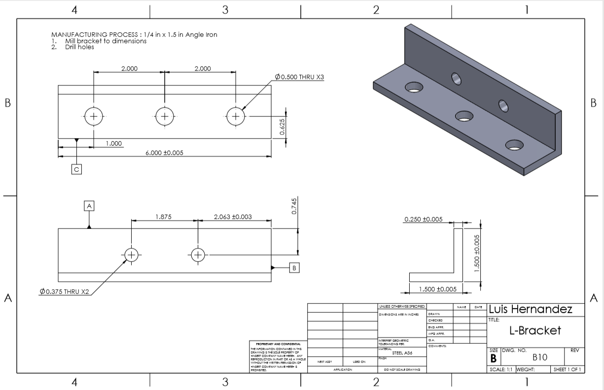
Drawing B-11-1: Steel Motor Mount Base Plate Short Side

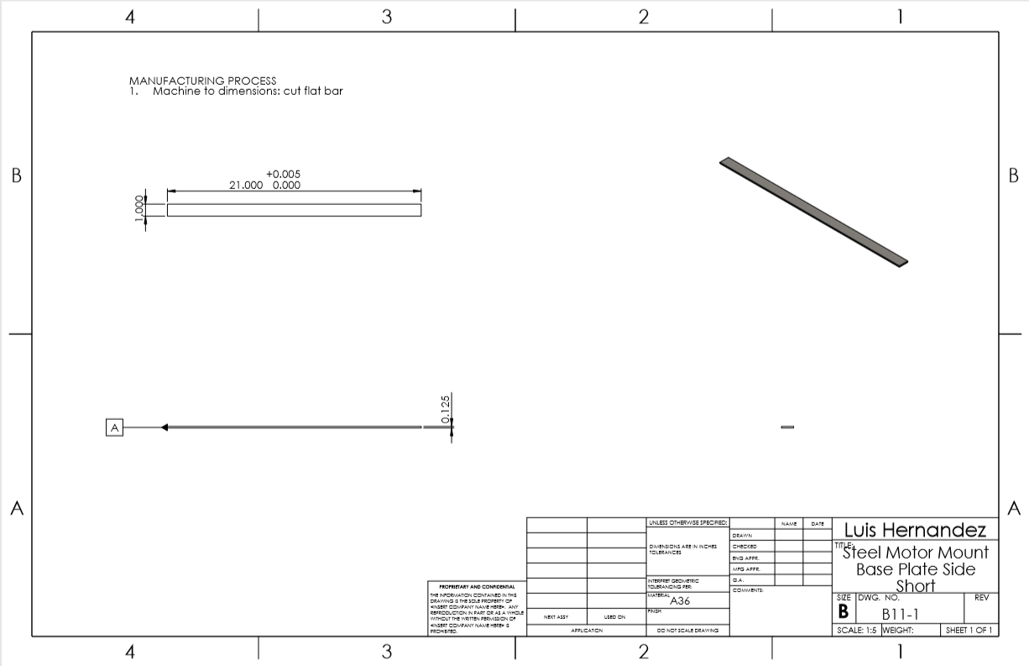
Drawing B-11-2: Steel Motor Mount Base Plate Side Long

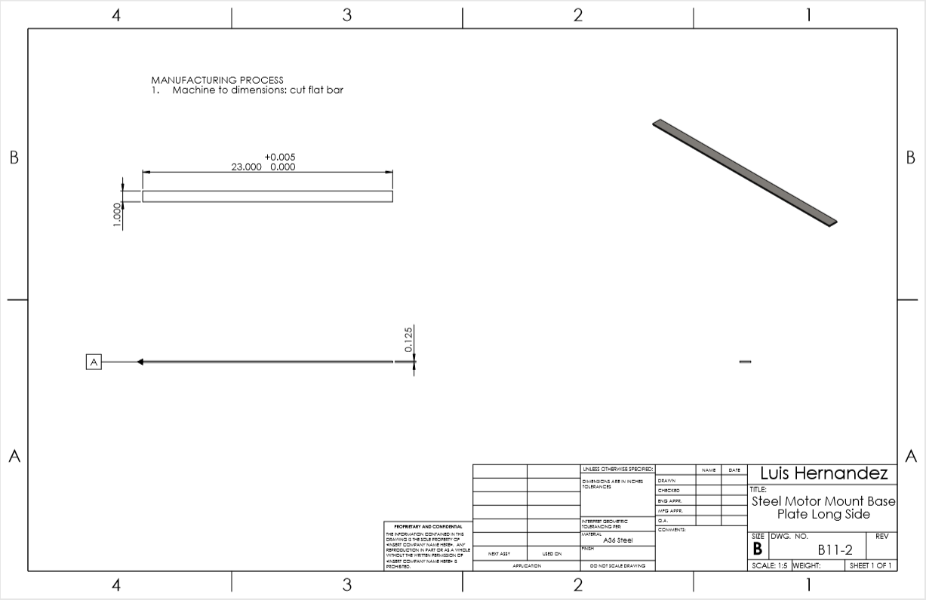
Drawing B-12: Steel Motor Mount Base Plate

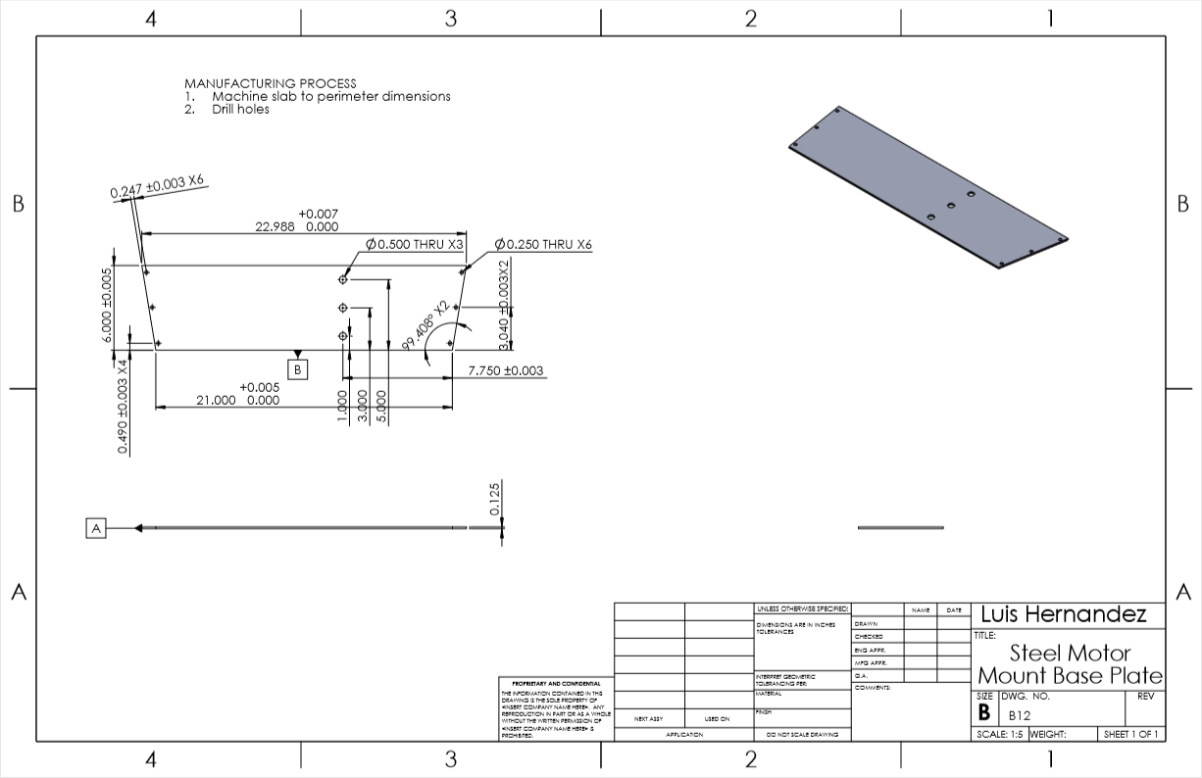
APPENDIX C – Parts List and Budget

APPPENDIX D – Schedule

APPENDIX E – Job Hazard Analysis Form

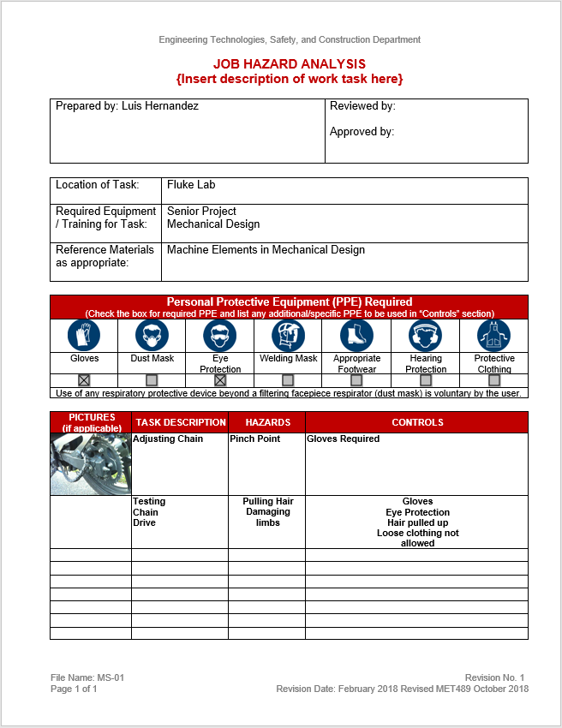
Luis G. Hernandez APPENDIX F - Resume
1508 E Seattle Ave
Ellensburg, WA 98926
425-429-8610
hernanluis@cwu.edu

Seeking internship position utilizing my knowledge acquired in the field of mechanical engineering and team leadership, with an opportunity to learn and make a difference.
_____________________________________________________________________________________
COMMUNICATIONS
- Spoke in front of two hundred guests and other smaller groups as public speaker for Habitat for Humanity.
- Fluent and proficient in Spanish.
- Advocate of a Spanish speaking family selected for a Habitat for Humanity home.
- Volunteered for multiple Athletes for Kid’s community events with children and parents.
- Coordinated and supervised club events, meetings, and trips in the American Society of Mechanical Engineers (ASME).
- Ensure orders from the Platoon Commander are passed down, understood and accomplished to all 44 Marines in the platoon.
LEADERSHIP/TEAMWORK
- American Society of Mechanical Engineers: Central Washington University Chapter President.
- Graduated Marine Corps Military Occupancy School as Distinguished Honor Graduate.
- Micromanaging artillery fire direction control center and Platoon Sergeant of Marines.
- Mentored a child diagnosed with a disability once a week for a year in Athlete’s for Kids.
- Mechanical Engineering Technology senior project Electrathon team leader.
- Graduated Marine Corps Officer Candidate’s School - Platoon Leaders Course; billeted as candidate platoon commander.
EDUCATION
- Central Washington University 2014 – Present (anticipated graduation: June 2019).
- Pursuing Bachelor of Science, Mechanical Engineering Technology (ABET accredited) with Minor in Mathematics.
- Six time Quarterly Honor Roll recipient.

Experience/Miscellaneous
- Sergeant in the United States Marine Corps Reserve 2013 – Present.
- Hardware and software engineer for programmable logic controller and sensor instrumentation.
- Proficient in AutoCAD, SolidWorks and LabVIEW.
- Former Quartermaster, ASME.
- Performed stage one upgrade and aesthetic changes on personal motorcycle.
- Costumer service at MOD Pizza and Student Union Recreation Center (SURC) Cafeteria.

